***Chemistry notes:***

***Topic 1 – Atomic Structure and the periodic table:***

**Atoms:**

All Substances are made atoms. An atom is the smallest part of an element that can exist.

* What do atoms contain?
  + Protons
    - Positive
  + Neutrons
    - Neutral
  + Electrons
    - Negative
* What is the radius of an atom?
  + 0.1 nanometres
    - 1 x 10-10
* The nucleus
  + It is found in the middle of the atom
  + It contains the protons and neutrons
  + A picture containing object

    Description automatically generatedThe radius is around 1 x 10-14
  + It has an overall positive charge
  + It makes up almost the whole mass of the atom
* The electrons
  + Move around the nucleus in electron shells
  + They are tiny but cover up a lot of space
  + The volume of their orbits determines the size of the atoms
* Atoms are neutral
  + This means that they no overall charge
    - This is because they have the same number of protons and electrons
    - The charge on the electrons is -1 and on the protons is +1
      * This means that they cancel out

**Elements:**

An element is a substance made up of atoms which all have the same number of protons in their nucleus.

* Atoms of each element are represented by a chemical symbol
  + There are about 100 elements in the periodic table
* An isotope is a different form of the same element, which have the same number of protons but a different number of neutrons
* Relative atomic mass (Ar) = Sum of (isotope abundance x isotope mass number) / sum of abundances of all the isotopes
  + The abundances are the amounts of all the isotopes that make up the element

**Compounds:**

* What are compounds?
  + Compounds are substances formed from two or more elements
    - The atoms of each are in fixed proportions throughout the compound and they’re held together by chemical bonds
      * Making bonds include the taking, giving away or sharing of electrons
* To separate the original elements of a compound you need to do a chemical reaction
* The properties are usually totally different to the original element

**Mixtures:**

* A mixture consists of two or more elements or compounds not chemically combined together.
  + The chemical properties of each substance in the mixture are unchanged.
    - This means that they are easily separated by physical methods
      * Such as, filtration, crystallisation, simple and fractional distillation and chromatography
    - These physical processes do not involve chemical reactions and no new substances are made.

* Crystallisation
  + Method

1. Pour solution into an evaporating dish and gently head the solution
   1. Some of the solvent will evaporate and the solution will be more concentrated
2. Once some has been evaporated, place it in a cool place
   1. Crystals will be formed
3. Filter the crystals and leave in a warm place to dry

* Simple Distillation
  + Used to separate liquids
    - * Method

1. The solution is heated
   1. The part of the solution which has the lowest boiling point evaporates first
2. The vapour is then cooled, condenses and is collected (as a liquid)
3. The rest of the solution is left in the flask

* Fractional Distillation
  + Used to separate a mixture of liquids
    - * Method

1. Put the mixture in a flask and stick a fractionated column on top, then you heat it
2. The different liquids have different boiling points, so they’ll evaporate at different temperatures
3. As it goes up the fractionated column, it cools down
   1. When it reaches the boiling point, it condenses and is collected as a liquid

**History of the atom:**

The theory of atomic structure has changed over time with new experimental evidence leading to the current model being changed or replaced

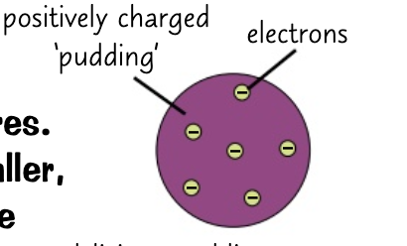

* At the start of the 19th century (before the electron was discovered)
  + John Dalton described atoms as tiny spheres that couldn’t be divided
* Plum Pudding, 1897 (the discovery of the electron)
  + JJ Thompson discovered the electron which led to the plum pudding model of the atom.
  + The plum pudding model suggested that the atom is a ball of positive charge with negative electrons embedded in it.
  + How?
    - JJ Thompson concluded that atoms weren’t solid spheres
    - His measurements of charge and mass showed that an atom must contain even smaller negatively charged electrons
    - This led to the plum pudding model
* Nuclear Model, 1909 (alpha scattering experiments)
  + Ernest Rutherford and his student Ernest Marsden conducted the famous alpha particle scattering experiments.
  + How did the experiment work?
    - They fired positively charged alpha particles at an extremely thin sheet of gold
      * They did this in order to see where the particles went
    - From the plum pudding model, they expected the particles to pass straight through or be a little bit deflected at most
  + What happened?
    - Three things were conducted from this experiment
      * Most of the atom was made up of empty space and there was a ‘cloud’ of electrons around the nucleus
        + 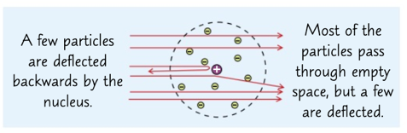This was concluded as most of the particles pass through it
      * The nucleus was positively charged and where there was the most mass
        + This was concluded as few particles rebound backwards, this meant that they were in a head on collision with a positive charge.
      * The nucleus was very small and concentrated
        + A picture containing object

          Description automatically generatedThis was concluded from the fact that some of the particles were deflected to the right or left after being near the nucleus
* Nuclear Model, adapted (Neils Bohr)
  + The idea that the electrons were in a ‘cloud’ around the nucleus was found to be faulted as this would cause the atom to collapse
  + Neils Bohr’s model suggested all the electrons orbit the nucleus at specific distances in fixed shells
  + It was supported by many experiments
* Existence of Neutrons, James Chadwick
  + Further experiments by Rutherford showed that the nucleus can be divided into smaller particles which have the same charge as a hydrogen nucleus
  + James Chadwick carried out an experiment which provided evidence for neutral particles in the nucleus called neutrons
  + This was about 20 years after the nucleus became accepted as a scientific idea
* Nuclear Model vs Plum Pudding
  + Nuclear model is more empty space
    - Plum pudding is a positively charged ball
  + Nuclear model has shells which contain electrons
    - Plum pudding has electrons embedded in it
  + Nuclear model has a nucleus
    - Plum pudding is a positively charged ball

***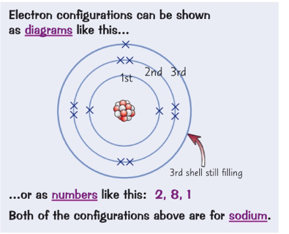*Electronic Structure:**

* Electrons always occupy shells
  + The lowest energy levels (closer to the nucleus) are always filled first
* Only a certain number of electrons are allowed in each shell
  + 1st shell: 2
  + 2nd shell: 8
  + 3rd shell: 8
* Atoms are ‘happier’ when they have a full outer shell (noble gases in group 0)
* In most atoms the outer shell is not full
  + This makes the atom want to react to fill it

**The Periodic Table:**

* ***Development of the periodic table:***
  + In the early 1800’s (before the discovery of protons, neutrons and electrons),
    - Elements were arranged by atomic mass
    - The early periodic tables were incomplete
      * Some elements were placed inappropriate groups
        + This is because it only was ordered in relative atomic mass and not grouped into properties
  + In 1869,
    - Dmitri Mendeleev overcame some of the problems, he did this by:
      * Leaving gaps for elements he thought had not been discovered
      * Changing the order of elements based on atomic weights
    - Elements with properties which Mendeleev predicted were discovered and filled the gaps
      * Knowledge of Isotopes made it possible to explain why the order based on atomic weights was not always correct
* ***Modern Periodic Table:***
  + There are around 100 elements
    - They are arranged:
      * By atomic number
      * So that elements with similar properties are in columns known as groups.
    - It is called a periodic table because similar properties occur at regular intervals
    - Elements in the same group in the periodic table have the same number of electrons in their outer shell (outer electrons)
      * This gives them similar chemical properties.

**Metals and Non-Metals:**

* Most elements are metals.
  + Metals are found to the left and the bottom of the periodic table
  + Non-Metals are found to the right and the top of the periodic table
* Metals are elements which form positive ions when they react
* Non-metals are elements which do not form positive ions when they react
* Differences:
  + They have different physical properties
    - Metals have metallic bonding which causes them to have similar basic physical properties:
      * They’re strong, malleable, good conductors of heat and electricity and they have high melting and boiling points
    - Non-Metals don’t have metallic bonding; therefore, they tend to be:
      * Brittle, have low melting and boiling points, don’t conduct electricity and have a low density

**Transition Metals:**

* A screenshot of a cell phone

  Description automatically generatedTransition metals are in the centre of the periodic table
* They are metals with similar properties
  + Their properties are those of a typical metal, these are:
    - They are good conductors of heat and electricity
    - They are dense, strong and shiny
* They also have special properties:
  + They can have more than one ion
    - Copper forms Cu+ and Cu2+ ions.
    - Cobalt forms Co2+ and Cu3+ ions.
  + They are often coloured and so compounds that contain them are colourful.
    - Potassium Chromate is yellow
    - Potassium manganate is purple
  + They make good catalysts
    - A nickel-based catalyst is used in the hydrogenation of alkanes
    - Iron catalyst is used in the Haber process for making ammonia

**Reactivity trends:**

* ***Group 1 (Alkali Metals)***
  + Lithium, Sodium, Potassium, Rubidium, Caesium, Francium
    - They all have one electron in their outer shell
      * This makes them very reactive and gives them all similar properties
    - They are soft and have low density
    - The trends as you go DOWN group 1 are:
      * Increasing reactivity
        + The outer electron is more easily lost

This is due to the attraction between the nucleus and electron decreasing as you go down the group

This happens as it the electron further away from the nucleus

* + - * Lower melting and boiling points
        + As there is less energy required to lose their outer electron
    - Group 1 elements readily form 1+ ions as they don’t need much energy to lose their outer electron
      * Due to this, they only ever react to form ionic compounds
        + These compounds are generally white solids which dissolve to form a colourless solution
  + Reactions:
    - Water (Metal + Water 🡪 Metal hydroxide + hydrogen)
      * When group 1 metals are put in water, they react vigorously to produce hydrogen gas and metal hydroxides
        + When the products are put in water, they dissolve and make alkaline solutions
      * The more reactive an alkali metal is, the more violent the reaction
      * The amount of energy released increases as you go down the group
    - Chlorine (Metal + Chlorine 🡪 Metal Chloride)
      * Group 1 metals react vigorously when heated in chlorine gas to form white metal chloride salts
      * As you go down the group, the chlorine reaction gets more vigorous
    - Oxygen (Metal + Oxygen 🡪 Metal Oxide)
      * Different types of Oxide will form depending on the metal
        + Lithium forms Lithium Oxide
        + Sodium forms Sodium Oxide and Sodium Peroxide
        + Potassium reacts to form Potassium Peroxide and Potassium superoxide
* 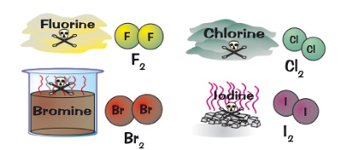***Group 7 (Halogens)***
  + Fluorine - A very reactive, poisonous yellow gas
  + Chlorine - A fairly reactive, poisonous dense green gas
  + Bromine - A dense, poisonous, red brown volatile liquid
  + Iodine - A dark grey crystalline solid or a purple vapour
  + They are all diatomic and they have similar reactions as they all have seven electrons in their outer shell.
  + Trends:
    - As you go DOWN group 7:
      * Reactivity decreases
        + It is harder to gain an extra electron, because the outer shell is further from the nucleus
      * Higher Melting and Boiling points
  + Halogens can share electrons via covalent bonding with other non-metals to complete a full outer shell.
  + Halogens form 1- ions called Halides (F‑, Cl-, Br-, I-) when they bond with metals
    - The compounds that form have ionic structures
  + A displacement reaction can occur between a more reactive halogen and the salt of a less reactive one
* ***Group 0 (Noble Gases)***
  + Helium, Neon, Argon…
  + They have a full outer shell
    - This means they are stable and don’t lose or gain electrons – meaning they aren’t as reactive
  + They’re colourless gasses at room temperature and not flammable
  + As you go DOWN the group:
    - The boiling points increase
      * This is due to an increase in the number of electrons in each atom leading to greater intermolecular forces which require more energy to break